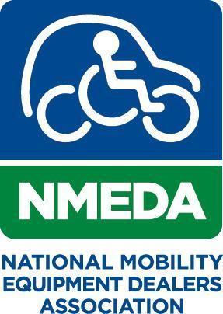Your logo here

For more information contact:
Your Name Here
Your Email Here
Your Phone Number Here

Your Company Here & NMEDA Celebrate the 9th Annual
National Mobility Awareness Month

See page 11 and 12 in the NMAM Guidebook for additional guidance.

Your City and State here – May 4, 2021 - “Say Hello to New Destinations” as Your Company Name here with a hyperlink to your website celebrate the 9th Annual National Mobility Awareness Month with the National Mobility Equipment Dealers Association (NMEDA).

This annual event is designed to educate seniors, veterans, caregivers, partners in the community, and people with disabilities about wheelchair accessible vehicles and the many adaptive mobility equipment options available to live an active, mobile lifestyle.

Quote from your company executive here:
Example: “We are excited to continue our support of National Mobility Awareness Month,” says Danny Langfield, NMEDA’s Chief Executive Officer. “This is a great opportunity for not only our partners but also the community to get involved and highlight mobility solutions which greatly impact those around us.”

A statistic you would like to share here:
Example: One in seven adults in the United States and Canada have mobility challenges, and four-fifths of wheelchair users report that their local public transportation system is difficult to use or get to.

Information about what you are doing to celebrate the month or inspirational story here:

To learn more about our efforts for National Mobility Awareness Month and to get involved, please visit your social media pages link here or your website link here or NMEDA.org/nmam.

Information About Your Company Here:

###

